HLD Architecture Agentic AI Project Management

Contents
Contents
HLD Architecture Agentic AI Project Management 1
Memory and Data Layer 3
Short-term Context 3
Long-term memory (LTM) is the copilot's persistent knowledge base — it survives across sessions and is what makes the copilot feel like it "knows" your project over time rather than starting fresh each conversation. 4
Vector search is the retrieval engine that makes long-term memory actually usable — without it, the copilot would have to stuff every stored fact into the context window at once, which is impossible at scale 5
Foundation LLM: 7
this is an area where the design choices matter a lot for both cost and quality. Here's how the LLM layer is typically structured for a copilot like this: Foundation LLM — Claude handles reasoning and language tasks, a code model handles generation, and an embedding model powers the semantic layer. LLM outputs feed back up to the orchestrator to close the loop. 7
Conclusion 8

Here's the full architecture for an AI PM Copilot designed for agentic software development. The system is organized into 5 layers:
1.User interface — teams interact via a PM dashboard, chat/voice, an IDE plugin, or CLI depending on their workflow.
2. Orchestration core — a single orchestrator agent is the brain: it holds the goal state, routes tasks to specialists, manages memory retrieval, and chains multi-step reasoning across the session.
3. Specialist agents — five domain-focused sub-agents handle distinct PM functions: writing requirements and acceptance criteria, sprint planning with velocity modeling, risk and dependency analysis, code/PR quality gating, and daily standup digest generation.
4. Tool integrations — agents act on the real project by calling tools for issue trackers (Jira, Linear), version control (GitHub/GitLab), CI/CD pipelines, comms (Slack/Teams), and docs (Confluence/Notion).
5. Memory and data — a three-tier memory model: short-term session context, long-term project history and team patterns, and a vector store for semantic search and RAG over codebases and docs.
Foundation LLM — Claude handles reasoning and language tasks, a code model handles generation, and an embedding model powers the semantic layer. LLM outputs feed back up to the orchestrator to close the loop.
Click any node to ask a deeper question about that component.

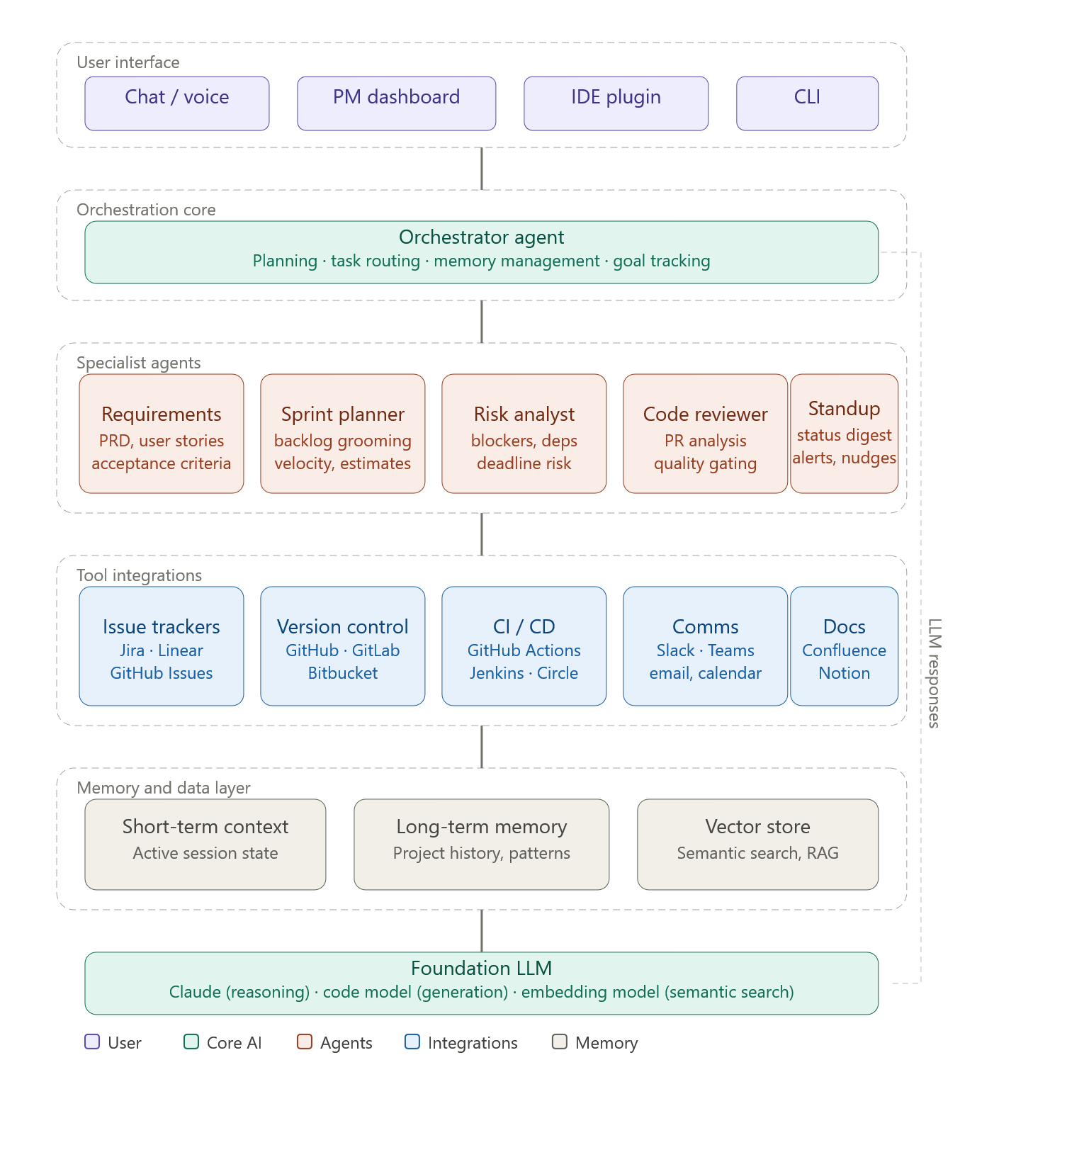

Memory and Data Layer

Short-term Context
Short-term context in the copilot is essentially the LLM's active working memory for one session — everything the model can "see" right now. Here's how it works:
What lives in the window (bottom to top)
The context is built in layers. At the base sits the system prompt — the agent's standing instructions, tool definitions, and persona. Above that, retrieved long-term memories are injected at session start (past sprint data, team preferences, known blockers). As the session progresses, tool outputs pile in — Jira tickets fetched, PR diffs loaded, CI status polled, RAG snippets retrieved from the vector store. On top of all that sit the live conversation turns: the user's messages, the agent's replies, sub-agent results, and the orchestrator's reasoning traces.
How it grows
Every time the user sends a message, a new turn is appended. Every time an agent calls a tool (check sprint board, fetch PR), the response is appended too. The window fills up from the inside out.
When it gets full
Context windows are finite (typically 100k–200k tokens for modern models, but the copilot budgets a working slice of this for each interaction). When turns start crowding out the headroom, a compression step kicks in: older conversation turns are summarised and the summary is written to long-term memory, then the raw turns are evicted. The window stays lean; nothing important is lost.
When the session ends
The entire window is wiped. Before that happens, the orchestrator extracts key decisions, task state changes, and anything worth remembering into the long-term memory store — so the next session can pick up where this one left off.
Click any node in the diagram to go deeper on a specific part of the lifecycle.

Long-term memory (LTM) is the copilot's persistent knowledge base — it survives across sessions and is what makes the copilot feel like it "knows" your project over time rather than starting fresh each conversation.
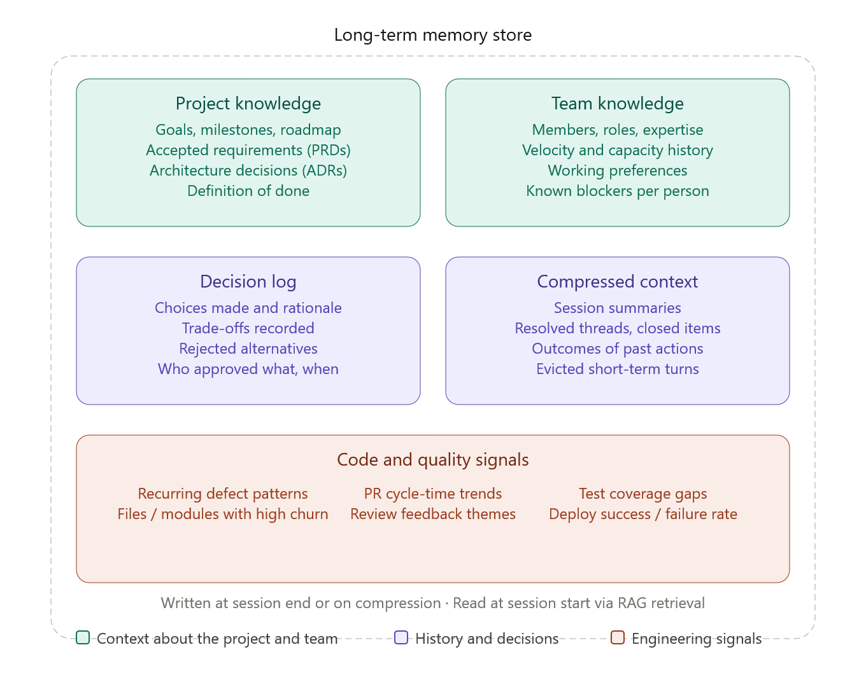
Here's what gets stored in each of the five categories:
Project knowledge is the stable foundation — the roadmap, accepted requirements, architecture decision records, and the team's definition of done. This rarely changes but is critical for the copilot to give contextually correct answers (e.g. "is this feature in scope for Q3?").
Team knowledge is the copilot's model of the humans it works with — who owns what, each person's typical velocity, their working style preferences, and any recurring blockers that have been flagged. This is what lets standup digests and task assignments feel personalised rather than generic.
Decision log is arguably the most valuable category over time. Every significant choice — which approach was picked, why the alternative was rejected, who signed off — gets recorded. This gives the copilot the ability to say "we decided not to use GraphQL in sprint 4 because of X" months later, and prevents the team from relitigating settled questions.
Compressed context is the distilled residue of past sessions. When short-term context fills and turns get evicted, they're summarised here. Closed tickets, resolved debates, completed investigations — they don't need to live in full detail, but a summary keeps the copilot from asking questions it already knows the answer to.
Code and quality signals are patterns extracted from the engineering toolchain over time — which modules keep breaking, which PRs drag, where test coverage is thin, what reviewers keep flagging. This is what lets the risk agent get sharper over time rather than treating every sprint as if it were the first.
All of this is written to the store either when a session ends or during context compression mid-session, and retrieved at the start of each new session via semantic (RAG) search — so only the most relevant memories get injected back into the active context window.



Vector search is the retrieval engine that makes long-term memory actually usable — without it, the copilot would have to stuff every stored fact into the context window at once, which is impossible at scale
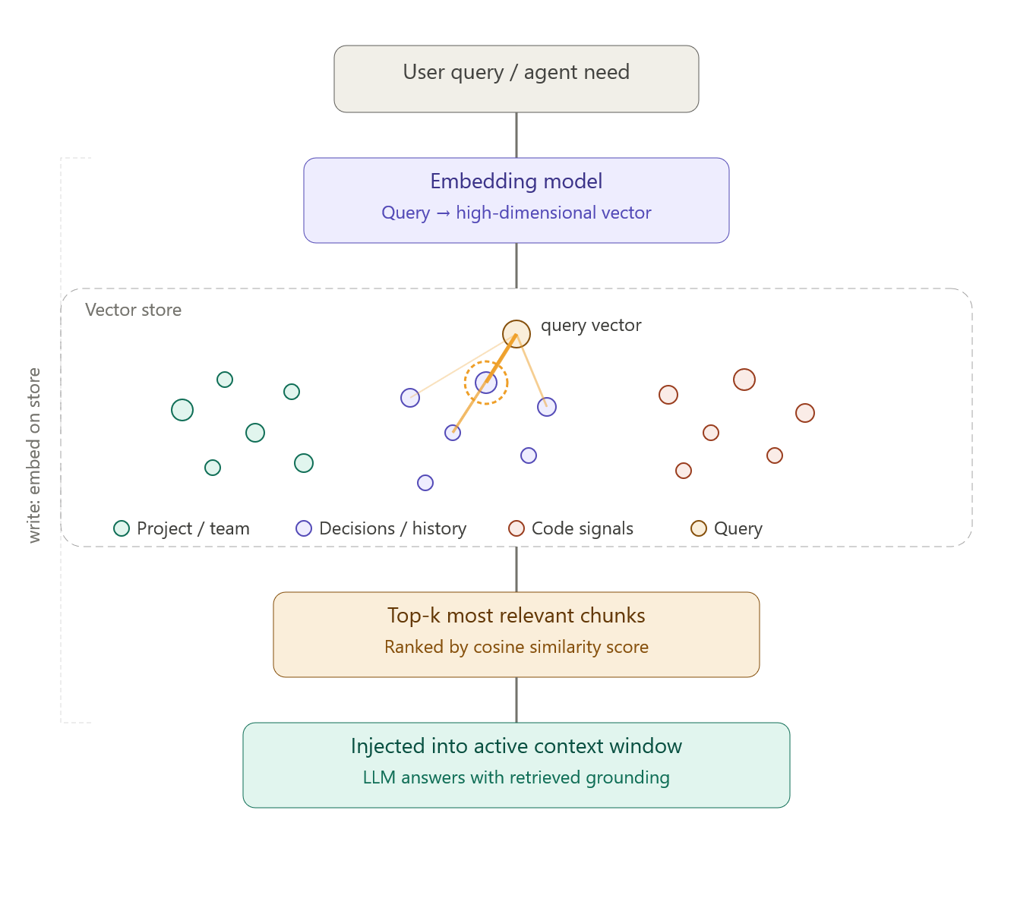
Here's the full picture of how it works:
Write path — when something is stored
Whenever a new memory is written (end of session, decision logged, ADR saved, code signal recorded), it passes through the embedding model first. The embedding model converts that chunk of text into a high-dimensional vector — a list of numbers that encodes its semantic meaning. That vector, along with the original text, is stored in the vector database. Every memory in the store has its own vector.
Read path — when the copilot needs to recall something
When a user asks something ("what did we decide about the auth approach?") or an agent needs context before acting, the same embedding model converts the query into a vector. The vector store then performs a nearest-neighbour search — finding stored vectors whose directions are mathematically closest to the query vector (measured by cosine similarity). These are the memories that mean something similar, not just ones that share the same keywords.
Top-k retrieval
The store returns the top-k most similar chunks (typically 3–10), ranked by similarity score. Only these get injected into the active context window. This is the key insight: instead of loading all of long-term memory (which would overflow any context window), the copilot loads only the most relevant slice for this specific moment.
Why this matters for the PM copilot specifically
The vector store holds memories across all five LTM categories — project knowledge, team knowledge, decision log, compressed context, and code signals. A question about sprint risk might surface relevant items from the decision log and code signal categories simultaneously, even if those items were stored months apart, because they're semantically related to the query. That cross-category retrieval is something keyword search alone can't do.

Foundation LLM:

this is an area where the design choices matter a lot for both cost and quality. Here's how the LLM layer is typically structured for a copilot like this: Foundation LLM — Claude handles reasoning and language tasks, a code model handles generation, and an embedding model powers the semantic layer. LLM outputs feed back up to the orchestrator to close the loop.
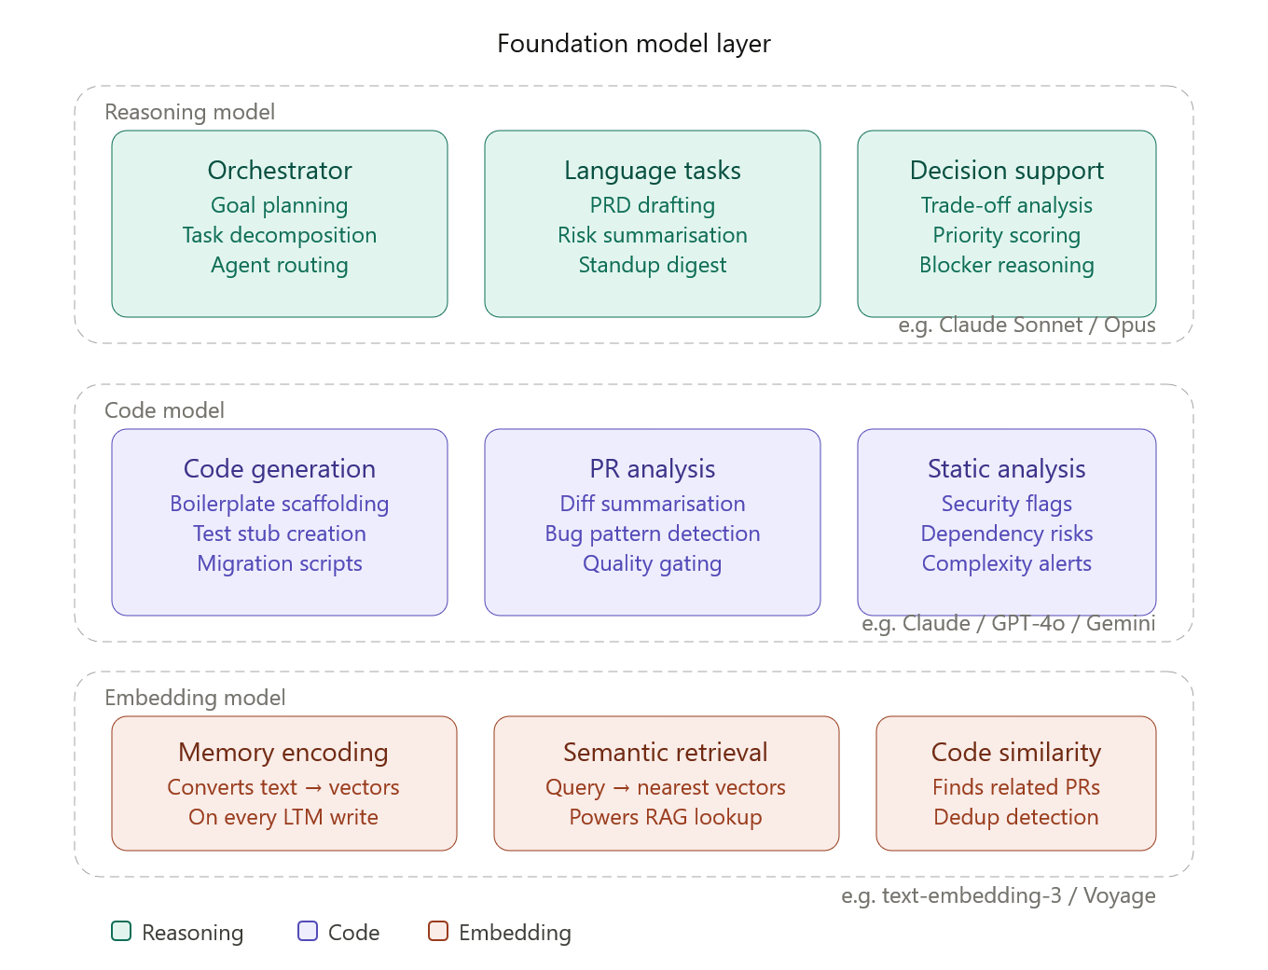
Three distinct model roles, each optimised for a different job:
Reasoning model — the "thinking" layer
This is the most capable and most expensive model in the stack, used sparingly for tasks that require genuine reasoning: orchestrating multi-step plans, decomposing ambiguous goals into agent tasks, writing PRDs, analysing trade-offs, and synthesising risk summaries from noisy data. Claude (Sonnet or Opus) is the natural fit here — it handles long, structured context well and produces coherent, nuanced language outputs. You wouldn't want to call this model for every tool lookup, but for anything requiring judgment, it's the right choice.
Code model — the "engineering" layer
A code-specialised model handles PR diffs, bug pattern detection, test stub generation, and static analysis flags. This can be Claude too (which scores very well on coding benchmarks), or a dedicated code model like GPT-4o or Gemini if the team has existing infra around those. The key property needed here is high precision on structured, syntactic content rather than broad reasoning depth.
Embedding model — the "memory" layer
This is a lightweight, fast model that runs constantly in the background. Every time something is written to long-term memory, it embeds the text into a vector. Every time a query comes in, it embeds that too. It never generates prose — it just converts text to numbers. OpenAI's text-embedding-3-large and Voyage AI's models are popular choices here, optimised for retrieval quality and throughput rather than generation quality.
The key design principle
Route each task to the cheapest model that can do it well. Embedding calls happen hundreds of times a session — those should be fast and cheap. Code review on a 200-line diff is a code-model job. "Should we cut this feature from the sprint given our velocity and the dependency on the auth team?" is a reasoning-model job. Getting this routing right is what keeps the copilot both high-quality and economically viable.

Conclusion

